# **Automated Indoor Hydroponic System**

A Term Paper / Project Report

Submitted in the partial fulfillment of the requirements for the award of the degree of

# Bachelor of Technology in

Department of Electronics & Communication Engineering

By

2110040008 – Charulatha T.

2110040015 – B. Harshini Reddy

2110040122 –B. Panduranga

2110040099 – Varun Kumar G.

under the supervision of

# Dr Joshitha C, Associate Professor



Department of Electronics & Communication Engineering

K L E F, Off Campus-Hyderabad,

Aziz Nagar- 500075, Rangareddy (Dist), Telangana, India. April, 2023

**Declaration**

The (Term Paper/Project) Report entitled “Automated Indoor Hydroponic System“ is a record of bonafide work of Charulatha T, Harshini Reddy B, Panduranga B, Varun Kumar G, submitted in partial fulfillment for the award of B.Tech in “Electronics and Communication Engineering” to the K L University. The results embodied in this report have not been copied from any other departments/Universities/institutes.

<Signature of the Students >

**Certificate**

This is to certify that the Report entitled “Automated Indoor Hydroponic System ” is being submitted by of Charulatha T, Harshini Reddy B, Panduranga B, Varun Kumar G, submitted in partial fulfillment for the award of B.Tech in “Electronics and Communication Engineering” to the K L University is a record of bonafide work carried out under our guidance and supervision.

The results embodied in this report have not been copied from any other departments/ University/Institute.

## Signature of the Co-Supervisor Signature of the Supervisor

## Signature of the HOD Signature of the External Examine

**Acknowledgement**

It is great pleasure for me to express my gratitude to our honorable President Sri. Koneru Satyanarayana, for giving the opportunity and platform with facilities in accomplishing the project based laboratory report.

I express the sincere gratitude to our principal Dr. L. Koteshwararao for his administration towards our academic growth.

I record it as my privilege to deeply thank our pioneer DR. M Goutham, HOD-ECE for providing us the efficient faculty and facilities to make our ideas into reality.

I express my sincere thanks to our project supervisor Dr. C. Joshitha for her novel association of ideas, encouragement, appreciation and intellectual zeal which motivated us to venture this project successfully.

Finally, it is pleased to acknowledge the indebtedness to all those who devoted themselves

directly or indirectly to make this project a report success.

**Abstract**

The growth of plants depends on several factors, such as light, temperature, and most importantly, soil. An automated hydroponic system is a modern technology that allows plants to grow without soil. This system uses water and nutrients to deliver essential elements to plant roots through a controlled environment. The automation of this system enables the control of plant growth factors, such as water, nutrient delivery, and light exposure, without the need for manual intervention. The system incorporates various sensors and controllers that monitor and regulate the system's environmental factors, such as temperature, humidity, and pH levels. Automated hydroponic systems offer several advantages, including higher crop yields, faster growth rates, and reduced water usage. This abstract aims to highlight the importance of automated hydroponic systems as a sustainable and efficient method of agriculture.

**Contents**

**Contents Page No.**

**Chapter 1:** Introduction 7

**Chapter 2:** Literature Survey 8

**Chapter 3:** Requirements 9

**Chapter 4:** Methodology 11

**Chapter 5:** Theoretical Analysis 19

**Chapter 6:** Conclusion 22

**Chapter 7:** References 23

**Table of figures**

**Contents Page No.**

Fig.1 9

Fig.2 9

Fig.3 9

Fig.4 10

Fig.5 10

Fig.6 10

Fig.7 11

Fig.8 12

Fig.9 12

Fig.10 13

Fig.11 13

**Chapter 1: Introduction**

The project team intends to provide an automated hydronic system. Through which the growth of hydroponics can be monitored easily. One can monitor room temperature, humidity, water dirtiness(freshness of water), nutrients in the water,ph of water,see if motors and fans are on or off, etc. All the above things will be displayed in the website and one can know about their plants anytime by looking at the website. Depending on the water’s dirtiness and PH vale , water will be automatically drained out and fresh water will be pumped in. Depending upon the temperature and light requirement of the plants temperature and light will be automatically controlled accordingly. Through this project ,most of the process can be automated which will decrease the difficult tasks that have to be done manually. Everything will be automated that hydroponic farms need.

**Chapter 2: Literature Survey**

This project consists of many features to handle indoor hydroponic system, we saw many embedded system designs which provides a single service, so we thought to combine all the services and provide and mini automated system

1. Design of an embedded system for water motor for planting

2. Monitoring temperature and humidity of plants

3. Interfacing of esp32 and humidity sensor

4. Interfacing of esp32 and water motor pump

5. Interfacing of esp32 and turbidity sensor

**Chapter 3: Requirements**

**ESP 32-**

The ESP32 is a low-cost, low-power system on a chip (SoC) microcontroller with integrated Wi-Fi and Bluetooth capabilities. It is widely used in IoT applications and projects.

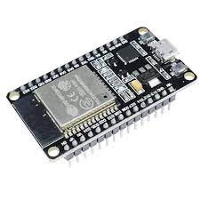

fig.1

**5V Relay Module-**

A 5V relay is an electronic switch that allows a low-voltage circuit to control a high-voltage circuit. It is often used to control motors or other high-power devices.

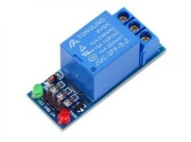

fig.2

**Water Motor-**

A water motor is a mechanical device that uses the power of water to generate rotary motion. It is often used in rural areas where electricity is not available for pumping water from wells or other sources.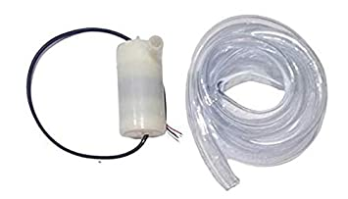

fig.3

**Jumper Wires-**

Jumper wires are used to connect the various components of the whole Automatic Plant Watering System. 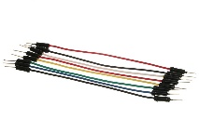

fig.4

**Humidity and temperature Sensor-**

A humidity and temperature sensor is a device that measures the level of humidity and temperature in the surrounding environment. It is commonly used in HVAC systems, weather stations, and indoor gardening applications.

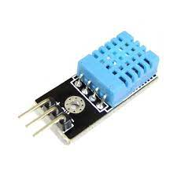

fig.5

**Turbidity sensor-**

A turbidity sensor is a device that measures the degree to which water loses its transparency due to the presence of suspended particulates. It is commonly used in water treatment plants, breweries, and other industries that require precise water quality monitoring.

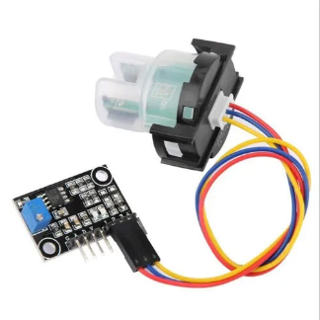

fig.6

**Chapter 4: Methodology**

This is a code for a hydroponic system that uses an ESP32 microcontroller to monitor temperature, humidity, and turbidity levels, as well as control a fan and two motors. It also sets up a web server to display the readings and allow for fan and motor control.

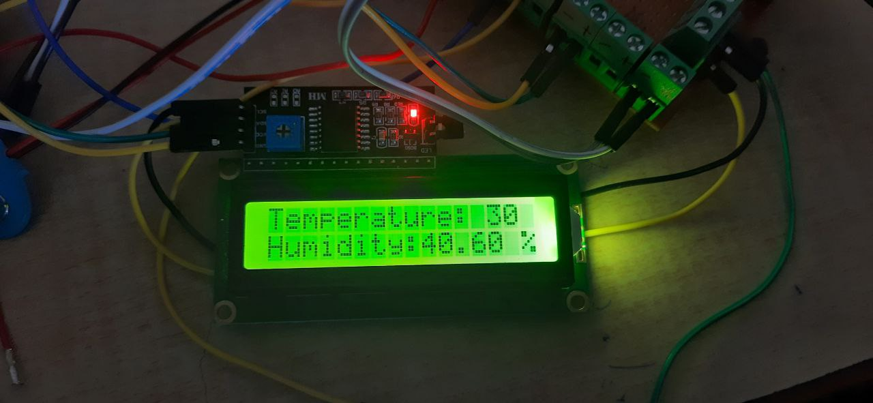

fig.7

**LCD display for automated indoor hydroponic system**

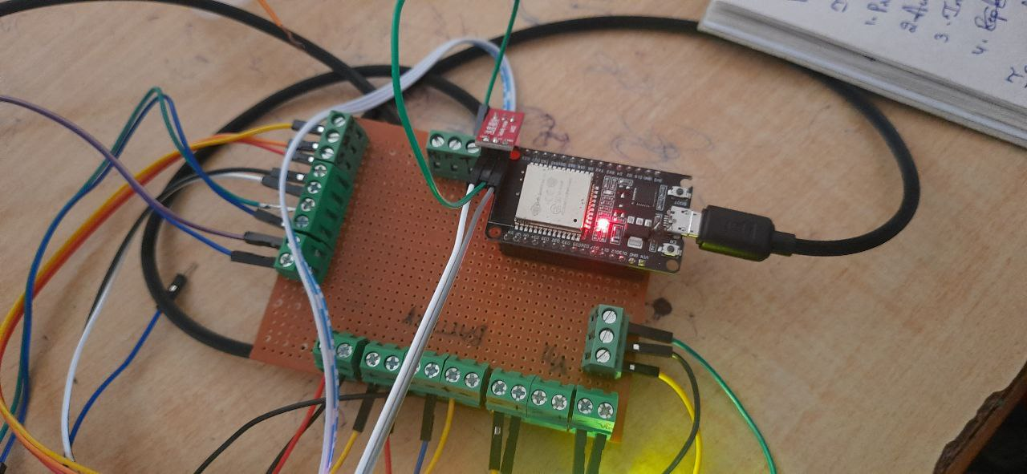

fig.8

**Circuit system for automated indoor hydroponic system**

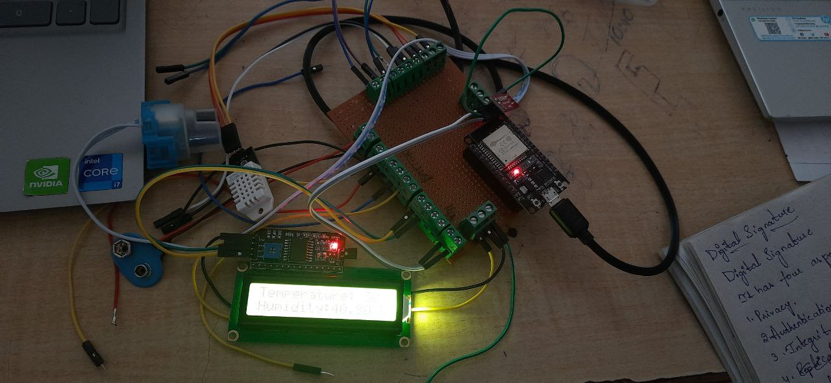

fig.9

**Circuit system for automated indoor hydroponic system**

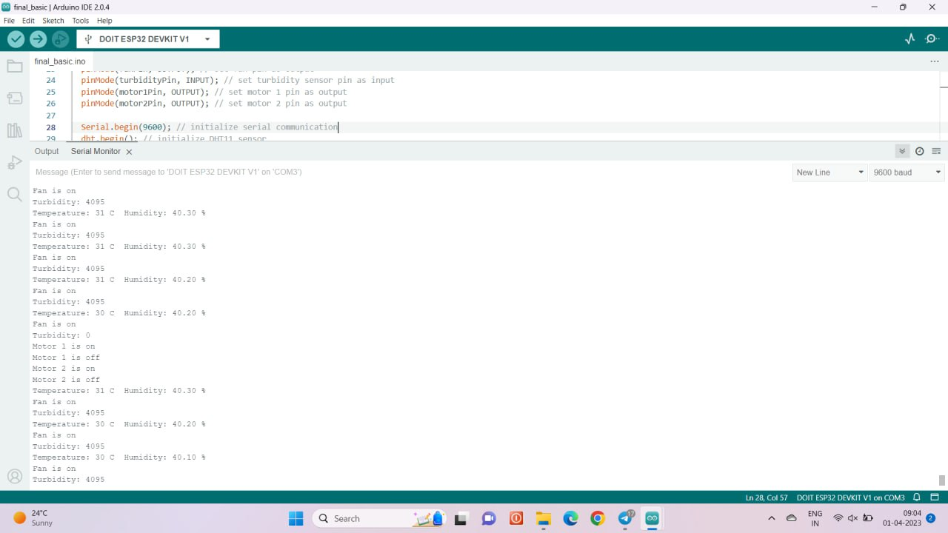

fig.10

**Code simulation results in serial monitor for automated indoor hydroponic system**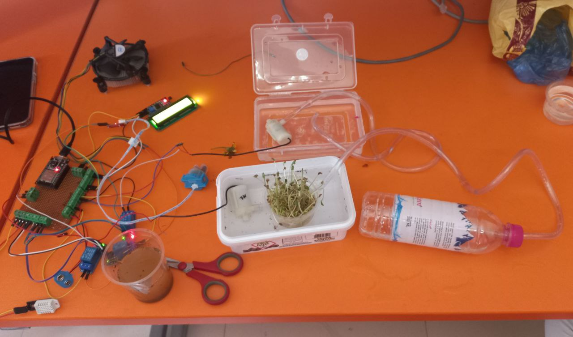

fig.11

**Code:**

#include <DHT.h>

#include <Wire.h>

#include <LiquidCrystal_I2C.h>

#include <WiFi.h>

#include <ESPAsyncWebServer.h>

#define DHTPIN 33

#define DHTTYPE DHT22

DHT dht(DHTPIN, DHTTYPE);

int fanPin = 27;

int temp = 0;

int setTemp = 31;

int turbidityPin = 36;

int motor1Pin = 14;

int motor2Pin = 15;

int turbidity = 0;

LiquidCrystal_I2C lcd(0x3f, 16, 2);

//SDA pin on the LCD to the SDA pin on the ESP32 board (usually pin 21)

//SCL pin on the LCD to the SCL pin on the ESP32 board (usually pin 22)

const char* ssid = "KLH BH";

const char* password = "klh@80y5";

AsyncWebServer server(80);

void setup() {

pinMode(fanPin, OUTPUT); // set fan pin as output

pinMode(turbidityPin, INPUT); // set turbidity sensor pin as input

pinMode(motor1Pin, OUTPUT); // set motor 1 pin as output

pinMode(motor2Pin, OUTPUT); // set motor 2 pin as output

Serial.begin(9600); // initialize serial communication

dht.begin(); // initialize DHT11 sensor

lcd.init(); // initialize LCD

lcd.backlight(); // turn on backlight

lcd.setCursor(0,0);

lcd.print("Temp: ");

lcd.setCursor(0,1);

lcd.print("Humidity: ");

lcd.setCursor(10,0);

lcd.print("Turbidity: ");

// Connect to WiFi

WiFi.begin(ssid, password);

while (WiFi.status() != WL_CONNECTED) {

delay(1000);

Serial.println("Connecting to WiFi...");

}

// Print the WiFi connection details

Serial.println("");

Serial.println("WiFi connected");

Serial.print("IP address: ");

Serial.println(WiFi.localIP());

// Configure web server routes

server.on("/", HTTP_GET, [](AsyncWebServerRequest *request){

String html = "<html>";

html += "<head><style>body { background-image: url('https://images.pexels.com/photos/4199758/pexels-photo-4199758.jpeg?cs=srgb&dl=pexels-pragyan-bezbaruah-4199758.jpg&fm=jpg'); }</style></head>";

html += "<body>";

String motorStatus = "Off";

if (digitalRead(motor1Pin) == HIGH && digitalRead(motor2Pin) == LOW) {

motorStatus = "Draining";

} else if (digitalRead(motor1Pin) == LOW && digitalRead(motor2Pin) == HIGH) {

motorStatus = "Adding Fresh Water";

}

html += "<h1><center><u>Welcome to the Hydroponi System</u></center></font color></h1>";

html += "<h2>Current Temperature: " + String(temp) + " C</h2>";

html += "<h2>Current Turbidity: " + String(turbidity) + "</h2>";

html += "<h2>Current Humidity: " + String(dht.readHumidity()) + "%</h2>";

html += "<h2>Fan Control</h2>";

html += "<form method='post' action='/fan'>";

html += "<input type='submit' name='fan' value='On'>";

html += "<input type='submit' name='fan' value='Off'>";

html += "</form>";

html += "<h2><center>Water Control</center></h2>";

html += "<form method='post' action='/water'>";

html += "<input type='submit' name='water' value='Drain and Add Fresh Water'>";

html += "<h2><center>Motor Status: " + motorStatus + "</center></h2>";

html += "</body></html>";

html += "</form>";

html += "</body></html>";

request->send(200, "text/html", html);

});

server.on("/fan", HTTP_POST, [](AsyncWebServerRequest *request){

if (request->hasParam("fan")) {

String fanStatus = request->getParam("fan")->value();

if (fanStatus == "On") {

digitalWrite(fanPin, HIGH);

} else if (fanStatus == "Off") {

digitalWrite(fanPin, LOW);

}

}

request->send(200);

});

server.on("/water", HTTP_POST, [](AsyncWebServerRequest *request){

digitalWrite(motor1Pin, HIGH);

digitalWrite(motor2Pin, LOW);

delay(5000);

digitalWrite(motor1Pin, LOW);

digitalWrite(motor2Pin, LOW);

request->send(200);

});

server.begin();

}void loop() {

delay(2000); // wait for 2 seconds

float humidity = dht.readHumidity(); // read humidity from DHT11

float temperature = dht.readTemperature(); // read temperature from DHT11 in Celsius

if (isnan(humidity) || isnan(temperature)) {

Serial.println("Failed to read from DHT11 sensor!"); // error message if failed to read from DHT11

temp=setTemp;

}else{

temp = temperature; // assign temperature value to temp variable

}

lcd.setCursor(0,0);

lcd.print("Temperature: ");

lcd.print(temp);

lcd.print(" C ");

lcd.setCursor(0,1);

lcd.print("Turbidity: ");

lcd.print(turbidity);

lcd.print("% ");

Serial.print("Temperature: ");

Serial.print(temp);

Serial.print(" C Humidity: ");

Serial.print(humidity);

Serial.println(" %");

delay(2000); // wait for 2 seconds

lcd.setCursor(0,1);

lcd.print("Humidity: ");

lcd.print(humidity);

lcd.print(" %");

turbidity = analogRead(turbidityPin);

lcd.setCursor(0,0);

lcd.print(" "); // clear the first line of the LCD display

Serial.print("Humidity: ");

Serial.print(humidity);

Serial.print(" % Turbidity: ");

Serial.println(turbidity);

delay(2000); // wait for 2 seconds

if (temp > setTemp) {

digitalWrite(fanPin, HIGH); // turn on fan if temperature is above set temperature

Serial.println("Fan is on");

}

else if (temp < setTemp) {

digitalWrite(fanPin, HIGH); // turn on fan if temperature is above set temperature

Serial.println("Fan is on");

}

else{

digitalWrite(fanPin, LOW); // turn off fan if temperature is below set temperature

Serial.println("Fan is off");

}

// turbidity sensor

// turbidity sensor

turbidity = analogRead(turbidityPin); // read turbidity value from sensor

Serial.print("Turbidity: ");

Serial.println(turbidity);

lcd.setCursor(0,0);

lcd.print("Temperature: ");

lcd.print(temp);

lcd.print(" C ");

lcd.setCursor(0,1);

lcd.print("Turbidity : ");

lcd.print(turbidity);

Serial.println("Motors are off");

lcd.setCursor(0,1);

lcd.print("Motors are off ");

if (turbidity < 500) {

digitalWrite(motor1Pin, HIGH); // turn on motor 1 to drain water if turbidity is high

Serial.println("Motor 1 is on");

lcd.setCursor(0,1);

lcd.print("Draining water... ");

while(1){

Serial.print("Turbidity: ");

Serial.println(turbidity);

int turbidityPin = 36;

turbidity = analogRead(turbidityPin); // read turbidity value from sensor

if(turbidity >=3000)

{

digitalWrite(motor1Pin, LOW); // turn off motor 1 after draining water

Serial.println("Motor 1 is off");

lcd.setCursor(0,1);

lcd.print(" fresh water .");

delay(5000); // wait for 5 seconds to add fresh water

digitalWrite(motor2Pin, HIGH); // turn on motor 2 to add fresh water

Serial.println("Motor 2 is on");

lcd.setCursor(0,1);

lcd.print(" water added. ");

delay(5000); // wait for 5 seconds to add fresh water

digitalWrite(motor2Pin, LOW); // turn off motor 2 after adding fresh water

Serial.println("Motor 2 is off");

lcd.setCursor(0,1);

lcd.print("Water cycle done. ");

break;

} } } }

**Chapter 5: Theoretical Analysis**

The project team intends to provide an automated hydronic system. Through which the growth of hydroponics can be monitored easily. One can monitor room temperature, humidity, water dirtiness(freshness of water), nutrients in the water, ph of water, see if motors and fans are on or off, etc. All the above things will be displayed on the website and one can know about their plants anytime by looking at the website. Depending on the water’s dirtiness and PH value, water will be automatically drained out and fresh water will be pumped in. Depending upon the temperature and light requirement of the plant temperature and light will be automatically controlled accordingly. Through this project, most of the process can be automated which will decrease the difficult tasks that need to be done manually. Everything will be automated that hydroponic farms need.

Hydroponic systems have been utilized as one of the standard methods for plant biology research and are also used in commercial production for several crops, including lettuce and tomato. Within the plant research community, numerous hydroponic systems have been designed to study plant responses to biotic and abiotic stresses. Here we present a hydroponic protocol that can be easily implemented in laboratories interested in pursuing studies on plant mineral nutrition.

This protocol describes the hydroponic system set up in detail and the preparation of plant material for successful experiments. Most of the materials described in this protocol can be found outside scientific supply companies, making the set up for hydroponic experiments less expensive and convenient.

The use of a hydroponic growth system is most advantageous in situations where the nutrient media need to be well controlled and when intact roots need to be harvested for downstream applications. We also demonstrate how nutrient concentrations can be modified to induce plant responses to both essential nutrients and toxic non-essential elements.

Hydroponics offers several advantages over soil-based systems. When removed from soil, root tissue is often mechanically sheared causing loss of tissue or damage. This is particularly true for fine root structures such as lateral roots and root hairs. Hydroponic systems that do not utilize an inert particulate media allow a less invasive separation of root and shoot tissues.

In soil systems, nutrient bioavailability changes throughout the soil matrix as nutrients bind to soil particles creating micro-environments within the soil. This heterogeneity could add an extra level of complexity in experiments needing a precise control on the external concentration of nutrients or other molecules. In contrast, the hydroponic solution is homogeneous and can be easily replaced throughout the course of the experiment.

Hydroponics, unlike traditional farming, does not require soil to grow food. In this technique, plants are grown either on natural or man-made substrates, where the roots easily extract the nutrients from a prepared nutrient solution. There are different methods for growing food using hydroponics, and their application depends on the specific plant, local climate, and budget, among other factors. Most systems comprise a storage tank for the nutrient solution and an aerator

**Variants of hydroponic systems**

All hydroponic cultures rely on a nutrient solution to deliver essential elements to the plant. In addition to the nutrients, the roots also need a steady supply of oxygen. When roots become anoxic they are unable to take up and transport metabolites to the rest of the plant body7. Hydroponic systems can be classified based on how they deliver oxygen and other nutrients to the roots: oxygen delivery by saturating the solution with air (classical hydroponics), by not submerging the roots at all times, or by allowing the roots to be completely exposed to the air (aeroponics)8. In hydroponics, nutrient solution can be saturated with air prior to its use and changed frequently, or air can be continuously supplied in the solution over the life cycle of the plant9. Alternatively, plants may also be grown on inert media (e.g., rockwool, vermiculite, or clay pellets) and subjected to wet-dry cycles by dripping solution through the media or periodically submerging the substrate in the nutrient solution10. In aeroponics, roots are sprayed with the nutrient solution to prevent desiccation.

Hydroponic Experiments

Nutrient solution replacement and manipulation

**Nutrient solution replacement**

To replace the nutrient solution, prepare fresh hydroponic solution as described in step 2.1. Remove the foam board containing plants from the hydroponic container and place it in a temporary container filled with water or hydroponic solution.

Discard the old solution, rinse the container briefly three times with DI water. Add the freshly prepared hydroponic solution into this container and gently place the foam board with plants back into the hydroponic container. Replace the hydroponic solution twice a week.

**Changing the nutrient composition of the hydroponic solution**

Adjust the composition of the hydroponic solution shown in Table 1 to modify the final concentration of an element of interest. For example, to induce iron (Fe) deficiency, modify the hydroponic solution to decrease the concentration of Fe-EDTA. Include a set of control plants grown on full (or replete) hydroponic solution, without any modification, for comparison.

To manipulate the nutrient solution with a toxic element, first prepare an independent stock solution of the desired toxic element, preferably 1,000x concentrated. Use a pipette to spike the hydroponic solution with the toxic element at the desired final concentration using the 1,000x concentrated stock.

For example, in order to make 3 L of hydroponic solution containing 20 µM of cadmium, prepare a 0.5 M CdCl2 stock, and add 120 µl of the 0.5 M CdCl2 stock into the 3 L hydroponic solution. Include a control set of plants grown on hydroponics without CdCl2 for comparison. CAUTION: Toxic elements such as cadmium, arsenic and lead are very dangerous for human health and the environment.

**Chapter 6: Conclusion**

It was observed that the proposed methodology controls the moisture content of the soil of cultivated land. The motor automatically starts pumping water if the soil is dry and needs water and stops when the moisture content of the soil is maintained as required. By using an esp32 and a few other components, we can create a system that will water plants based on their needs.

The implementation of an automated hydroponic system has the potential to revolutionize agriculture by providing a sustainable and efficient method of growing plants. This project aims to design and implement such a system, providing valuable insights into the development of automated hydroponic systems. The successful completion of this project will contribute to the advancement of sustainable agriculture and enable people to grow their own products using modern technology.

**Chapter 7: References**

chatgpt.com

<https://autogrow.com/our-products-solutions/hydroponics-substrates>

<https://www.cdac.in/index.aspx?id=pe_aee_AutomatedHydroponicsSystems>

https://levelup.gitconnected.com/automated-hydroponics-9aa697552b9d?gi=b4626ab45248